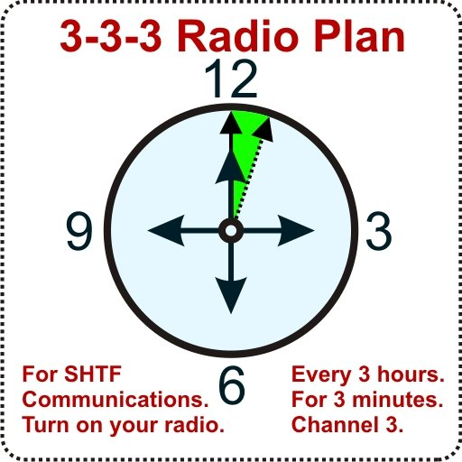

Radio  Service | Channel  Name | Freq Mhz  Mode | Description
CB | CB-3AM | 26.9850 AM
CB | CB-9AM | 27.0650 AM
MURS | MURS 1 | 151.8800 FM | 12.50kHZ
MURS | MURS 2 | 151.9400 FM | 12.50kHZ
MURS | MURS 3 | 154.5700 FM | 20.00kHZ
MURS | MURS 4 Green | 154.6000 FM | 20.00kHZ
FRS | FRS-3 | 462.6125 FM | 12.50kHZ
GMRS | GMRS-17 | 462.6000 FM | 20.00kHZ
GMRS | GMRS Repeater | ?????
HAM HF | HAM 10M | 28.3050 USB
HAM HF | HAM G10M | 28.3600 USB
HAM HF | HAM G10M | 29.6000 FM
HAM HF | HAM 20M | 14.2420 USB
HAM HF | HAM 20M | 14.3000 USB
HAM HF | HAM 40M | 7.2420 LSB
HAM HF | HAM 40M | 7.2720 LSB
HAM HF | HAM 60M | 5.3570 USB
HAM HF | HAM 80M | 3.8180 USB
HAM Vhf | HAM 6M | 52.5400 FM
HAM Vhf | HAM GTARC Vhf | 146.8050- FM | PL100.0
HAM Vhf | HAM 52 | 146.5200 FM
HAM Vhf | HAM 55 | 146.5500 FM
HAM Vhf | HAM 58 | 146.5800 FM
HAM Uhf | HAM 00 | 446.0000 FM
HAM Uhf | HAM 03 | 446.0300 FM
- Prepper & Survivalist SHTF Frequencies

✵ 3-3-3 RADIO PLAN - The Survivalist Radio Schedule
This is the “When, Where, and How” to make radio contact with each other for SHTF. The 333 Radio Plan was designed for SHTF communications, when normal methods of communication fail. Versions of the 3-3-3 are used by survivalist, prepper, and emergency communications groups worldwide. It is based on the easy-to-remember “Survival Rule of Threes”. It is often called an emergency radio schedule or sked.

✵ ABOUT THE 3-3-3 RADIO PLAN
Here’s how the 3-3-3 Radio Plan works:
Turn on your radio. Every 3 hours. For 3 minutes. Channel 3.
✵ WHEN: EVERY 3 HOURS
Always use your Local Time for local area communications with the 3-3-3 Radio Plan. At the “top of the hour”, each
3 hours: Noon, 3pm, 6pm, 9pm. Midnight, 3am, 6am, 9am.
✵ HOW LONG: FOR 3 MINUTES
At the top of every 3rd hour, turn on your radio. Even if you don’t need to make a call yourself, always turn on your radio and listen for calls for at least 3 minutes. This is because you never know if someone may be trying to reach you or may need help. If you need to check in, make a short transmission currently. Say “This is me, just checking in.” If you have sufficient battery power, or if you have not connected in for a while, then you should listen for 15 minutes.

✵ ACCURATE TIME KEEPING
Synchronize your watch with others whenever possible. If you
doubt your watch accuracy, compensate by keeping your radio on for a longer duration, before and after every 3rd hour. If you don’t have a watch, try listening to an AM broadcast radio station, they always identify their call letters at the top of each hour.
✵ WHERE: CHANNEL 3
Channel 3 usually applies to CB, FRS, or MURS. These are the most common types of radios used. If your group has a different designated SHTF channel or Prepper SHTF HAM frequency, you should use it instead of Channel 3.
For example, the ham 2 meter simplex calling channel 146.520 MHz The rest of the 3-3-3 Radio Plan remains the same. Keep it simple.

✵ HOW IT WORKS: FEATURES OF THE 3-3-3 RADIO PLAN
1. Easy for everyone to remember the “Rule of Three”.
2. Conserves precious battery life for walkie talkies.
3. Gets everyone on the air at the same time.
4. Sets a schedule of 8 times per day to call each other.
5. Avoids impractical hourly schedules.
6. Enables the use of short transmissions for optimum success
and security.
7. Three hours is enough time to rest in a survival situation.
8. A person can walk 8 miles in 3 hours, the practical distance limit of handheld radios over average terrain.

